**Wk11 Assignment: Junit**

# Problem Statement

Test any existing application Controller using Spring Junit & Mockito framework.

**Junit:**

**Requirement:**

Use Junit test cases for Controller CRUD operations.

**Mockito:**

**Requirement:**

Use Mockito test cases for Controller CRUD operations.

# Code Repository

The complete code can be found here-  
<https://github.com/singhayush20/Assignments/tree/main/Wk11_Testing/junit_mockito_demo>

# Project Structure

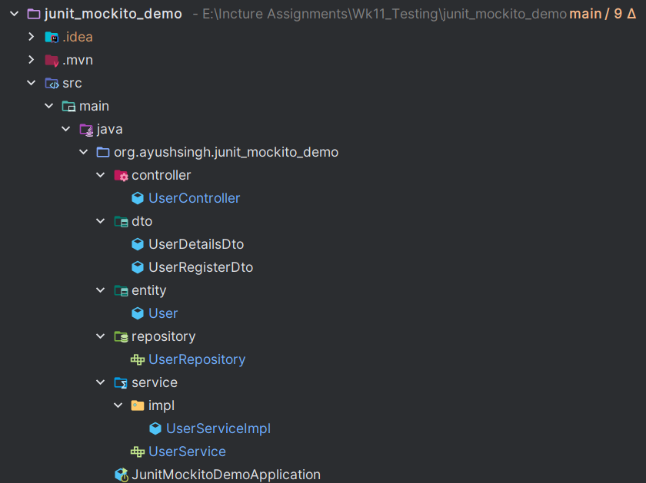

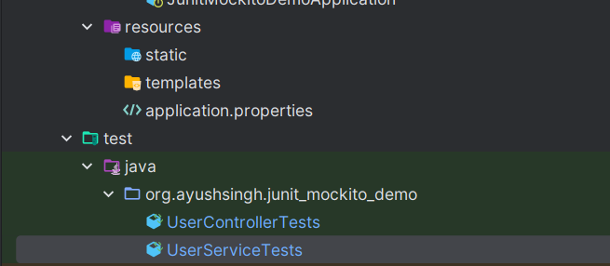

## Required dependencies

<dependency>  
 <groupId>org.springframework.boot</groupId>  
 <artifactId>spring-boot-starter-data-jpa</artifactId>  
</dependency>  
<dependency>  
 <groupId>org.springframework.boot</groupId>  
 <artifactId>spring-boot-starter-web</artifactId>  
</dependency>  
  
<dependency>  
 <groupId>org.springframework.boot</groupId>  
 <artifactId>spring-boot-devtools</artifactId>  
 <scope>runtime</scope>  
 <optional>true</optional>  
</dependency>  
<dependency>  
 <groupId>com.mysql</groupId>  
 <artifactId>mysql-connector-j</artifactId>  
 <scope>runtime</scope>  
</dependency>  
<dependency>  
 <groupId>org.projectlombok</groupId>  
 <artifactId>lombok</artifactId>  
 <optional>true</optional>  
</dependency>  
<dependency>  
 <groupId>org.mockito</groupId>  
 <artifactId>mockito-core</artifactId>  
 <version>5.11.0</version>  
 <scope>test</scope>  
</dependency>  
<dependency>  
 <groupId>io.rest-assured</groupId>  
 <artifactId>rest-assured</artifactId>  
 <version>5.4.0</version>  
 <scope>test</scope>  
</dependency>  
  
<dependency>  
 <groupId>org.springframework.boot</groupId>  
 <artifactId>spring-boot-starter-test</artifactId>  
 <scope>test</scope>  
</dependency>

## Entity

package org.ayushsingh.junit_mockito_demo.entity;  
  
import jakarta.persistence.*;  
import lombok.Getter;  
import lombok.Setter;  
  
import java.util.Objects;  
  
  
*/**  
 * Entity class representing a user in the system.  
 * This class is mapped to the 'user' table in the database.  
 *  
 * @author Ayush Singh  
 * @version 1.0.0  
 * @since 2024-04-12  
 */*@Table(name = "user")  
@Entity  
  
@Getter  
@Setter  
public class User {  
  
 @Id  
 @GeneratedValue(strategy = GenerationType.*IDENTITY*)  
 @Column(name = "user_id")  
 private Long userId;  
  
 @Column(name = "username", nullable = false)  
 private String username;  
  
 @Column(name = "password", nullable = false)  
 private String password;  
  
 @Column(name = "name", nullable = false)  
 private String name;  
  
 @Column(name = "email", nullable = false)  
 private String email;  
  
 @Column(name = "phone", nullable = false, length = 10)  
 private Long phone;  
  
  
 public User() {  
  
 }  
  
 public User(Long userId, String username, String password, String name, String email, Long phone) {  
 this.userId = userId;  
 this.username = username;  
 this.password = password;  
 this.name = name;  
 this.email = email;  
 this.phone = phone;  
 }  
  
 public User(String username, String password, String name, String email, Long phone) {  
 this.username = username;  
 this.password = password;  
 this.name = name;  
 this.email = email;  
 this.phone = phone;  
 }  
  
 @Override  
 public boolean equals(Object o) {  
 if (this == o) return true;  
 if (o == null || getClass() != o.getClass()) return false;  
 User user = (User) o;  
 return Objects.*equals*(username, user.username) && Objects.*equals*(password, user.password) && Objects.*equals*(name, user.name) && Objects.*equals*(email, user.email) && Objects.*equals*(phone, user.phone);  
 }  
  
 @Override  
 public int hashCode() {  
 return Objects.*hash*(username, password, name, email, phone);  
 }  
}

## Service and Implementation

package org.ayushsingh.junit_mockito_demo.service;  
  
import org.ayushsingh.junit_mockito_demo.dto.UserDetailsDto;  
import org.ayushsingh.junit_mockito_demo.dto.UserRegisterDto;  
  
import java.util.List;  
  
*/**  
 * Service interface for managing user-related operations.  
 * This interface defines methods to create, retrieve, update, and delete users,  
 * as well as retrieve a list of all users.  
 *  
 * @author Ayush Singh  
 * @since 2024-04-12  
 * @version 1.0.0  
 */*public interface UserService {  
  
 UserDetailsDto createUser(UserRegisterDto userRegisterDto);  
  
 UserDetailsDto getUser(Long userId);  
  
 List<UserDetailsDto> getAllUsers();  
  
 void deleteUser(Long userId);  
  
 UserDetailsDto updateUser(UserDetailsDto userDto);  
}

package org.ayushsingh.junit_mockito_demo.service.impl;  
  
import lombok.RequiredArgsConstructor;  
import org.ayushsingh.junit_mockito_demo.dto.UserDetailsDto;  
import org.ayushsingh.junit_mockito_demo.dto.UserRegisterDto;  
import org.ayushsingh.junit_mockito_demo.entity.User;  
import org.ayushsingh.junit_mockito_demo.repository.UserRepository;  
import org.ayushsingh.junit_mockito_demo.service.UserService;  
import org.springframework.stereotype.Service;  
  
import java.util.List;  
import java.util.Optional;  
import java.util.stream.Collectors;  
  
*/**  
 * Implementation of the UserService interface to manage user-related operations.  
 * This service class provides methods to create, retrieve, update, and delete user information.  
 *  
 * @author Ayush Singh  
 * @since 2024-04-12  
 * @version 1.0.0  
 */*@Service  
@RequiredArgsConstructor  
public class UserServiceImpl implements UserService {  
  
 private final UserRepository userRepository;  
  
  
 */**  
 * Create a new user with the provided details.  
 *  
 * @param userRegisterDto The details of the user to be created.  
 * @return UserDetailsDto with the details of the created user.  
 */* @Override  
 public UserDetailsDto createUser(UserRegisterDto userRegisterDto) {  
 User newUser = new User();  
 newUser.setUsername(userRegisterDto.getUsername());  
 newUser.setPassword(userRegisterDto.getPassword());  
 newUser.setName(userRegisterDto.getName());  
 newUser.setEmail(userRegisterDto.getEmail());  
 newUser.setPhone(userRegisterDto.getPhone());  
  
 User savedUser=userRepository.save(newUser);  
 return UserDetailsDto.*builder*()  
 .userId(savedUser.getUserId())  
 .username(savedUser.getUsername())  
 .name(savedUser.getName())  
 .email(savedUser.getEmail())  
 .phone(savedUser.getPhone())  
 .build();  
 }  
  
  
 */**  
 * Retrieve user details by userId.  
 *  
 * @param userId The unique identifier of the user.  
 * @return UserDetailsDto with the details of the user if found, otherwise null.  
 */* @Override  
 public UserDetailsDto getUser(Long userId) {  
 Optional<User> user = userRepository.findById(userId);  
 if (user.isEmpty()) {  
 return null;  
 }  
 return UserDetailsDto.*builder*()  
 .userId(user.get().getUserId())  
 .username(user.get().getUsername())  
 .name(user.get().getName())  
 .email(user.get().getEmail())  
 .phone(user.get().getPhone())  
 .build();  
 }  
  
  
 */**  
 * Retrieve details of all users.  
 *  
 * @return List*<*UserDetailsDto*> *with details of all users.  
 */* @Override  
 public List<UserDetailsDto> getAllUsers() {  
 List<User> users = userRepository.findAll();  
 return users.stream().map(user -> {  
 UserDetailsDto userDetailsDto = new UserDetailsDto();  
 userDetailsDto.setUserId(user.getUserId());  
 userDetailsDto.setUsername(user.getUsername());  
 userDetailsDto.setName(user.getName());  
 userDetailsDto.setEmail(user.getEmail());  
 userDetailsDto.setPhone(user.getPhone());  
 return userDetailsDto;  
 }).collect(Collectors.*toList*());  
 }  
  
  
 */**  
 * Delete a user by userId.  
 *  
 * @param userId The unique identifier of the user to be deleted.  
 */* @Override  
 public void deleteUser(Long userId) {  
 userRepository.deleteById(userId);  
 }  
  
  
 */**  
 * Update user details.  
 *  
 * @param userDto The updated details of the user.  
 * @return UserDetailsDto with the updated user details if found, otherwise null.  
 */* @Override  
 public UserDetailsDto updateUser(UserDetailsDto userDto) {  
 Optional<User> userOptional = userRepository.findById(userDto.getUserId());  
 if (userOptional.isEmpty()) {  
 return null;  
 }  
 User user = userOptional.get();  
 user.setUsername(userDto.getUsername());  
 user.setName(userDto.getName());  
 user.setEmail(userDto.getEmail());  
 user.setPhone(userDto.getPhone());  
 return UserDetailsDto.*builder*()  
 .userId(userRepository.save(user).getUserId())  
 .username(user.getUsername())  
 .name(user.getName())  
 .email(user.getEmail())  
 .phone(user.getPhone())  
 .build();  
 }  
}

## User Repository

package org.ayushsingh.junit_mockito_demo.repository;  
  
import org.ayushsingh.junit_mockito_demo.entity.User;  
import org.springframework.data.jpa.repository.JpaRepository;  
*/**  
 * Repository interface for managing user entities in the database.  
 * This interface extends JpaRepository provided by Spring Data JPA,  
 * which provides various methods for CRUD operations on the User entity.  
 *  
 * @author Ayush Singh  
 * @since 2024-04-12  
 * @version 1.0.0  
 */*public interface UserRepository extends JpaRepository<User, Long> {  
}

## UserController

package org.ayushsingh.junit_mockito_demo.controller;  
  
import lombok.RequiredArgsConstructor;  
import org.ayushsingh.junit_mockito_demo.dto.UserDetailsDto;  
import org.ayushsingh.junit_mockito_demo.dto.UserRegisterDto;  
import org.ayushsingh.junit_mockito_demo.service.UserService;  
import org.springframework.http.HttpStatus;  
import org.springframework.http.ResponseEntity;  
import org.springframework.web.bind.annotation.*;  
  
import java.util.List;  
  
*/**  
 * Controller class to handle user-related HTTP requests.  
 * This controller provides endpoints for creating, retrieving, updating, and deleting user information.  
 *  
 * @author Ayush Singh  
 * @version 1.0.0  
 * @since 2024-04-12  
 */*@RestController  
@RequestMapping("/api/v1/user")  
@RequiredArgsConstructor  
public class UserController {  
  
 private final UserService userService;  
  
  
 */**  
 * Endpoint to create a new user.  
 *  
 * @param userRegisterDto The details of the user to be created.  
 * @return ResponseEntity with the created user details.  
 */* @PostMapping("/create")  
 public ResponseEntity<UserDetailsDto> createUser(@RequestBody UserRegisterDto userRegisterDto) {  
 UserDetailsDto userDetailsDto = userService.createUser(userRegisterDto);  
 return ResponseEntity.*status*(HttpStatus.*CREATED*).body(userDetailsDto);  
 }  
  
 */**  
 * Endpoint to retrieve user details by userId.  
 *  
 * @param userId The unique identifier of the user.  
 * @return ResponseEntity with the user details.  
 */* @GetMapping("/{userId}")  
 public ResponseEntity<UserDetailsDto> getUser(@PathVariable Long userId) {  
 UserDetailsDto userDetailsDto = userService.getUser(userId);  
  
 return ResponseEntity.*ok*(userDetailsDto);  
  
 }  
  
 */**  
 * Endpoint to retrieve details of all users.  
 *  
 * @return ResponseEntity with a list of all users' details.  
 */* @GetMapping("/all")  
 public ResponseEntity<List<UserDetailsDto>> getAllUsers() {  
 List<UserDetailsDto> userDetailsDtoList = userService.getAllUsers();  
 return ResponseEntity.*ok*(userDetailsDtoList);  
 }  
  
 */**  
 * Endpoint to delete a user by userId.  
 *  
 * @param userId The unique identifier of the user to be deleted.  
 * @return ResponseEntity with no content.  
 */* @DeleteMapping("/{userId}")  
 public ResponseEntity<Void> deleteUser(@PathVariable Long userId) {  
 userService.deleteUser(userId);  
 return ResponseEntity.*noContent*().build();  
 }  
  
 */**  
 * Endpoint to update user details.  
 *  
 * @param userDetailsDto The updated details of the user.  
 * @return ResponseEntity with the updated user details.  
 */* @PutMapping("/update")  
 public ResponseEntity<UserDetailsDto> updateUser(@RequestBody UserDetailsDto userDetailsDto) {  
 UserDetailsDto updatedUser = userService.updateUser(userDetailsDto);  
  
 return ResponseEntity.*ok*(updatedUser);  
 }  
}

# Test using Junit and Rest Assured

package org.ayushsingh.junit_mockito_demo;  
  
import io.restassured.RestAssured;  
import io.restassured.http.ContentType;  
import org.ayushsingh.junit_mockito_demo.dto.UserDetailsDto;  
import org.ayushsingh.junit_mockito_demo.dto.UserRegisterDto;  
import org.junit.jupiter.api.*;  
import org.junit.jupiter.api.MethodOrderer.OrderAnnotation;  
import org.springframework.boot.test.context.SpringBootTest;  
  
import static io.restassured.RestAssured.*;  
import static org.hamcrest.Matchers.*;  
  
  
*/**  
 * Tests for the {@link org.ayushsingh.junit_mockito_demo.controller.UserController}.  
 * These tests use RestAssured to interact with the UserController endpoints.  
 *  
 * @author Ayush Singh  
 * @since 2024-04-12  
 * @version 1.0.0  
 */*@SpringBootTest(webEnvironment = SpringBootTest.WebEnvironment.*DEFINED_PORT*)  
@TestMethodOrder(OrderAnnotation.class)  
public class UserControllerTests {  
  
 private static Long *userId*;  
  
 @BeforeAll  
 public static void setUp() {  
 final String BASE_URL = "http://localhost:8086" + "/api/v1/user";  
 RestAssured.*baseURI* = BASE_URL;  
 *userId*=1L;  
 RestAssured.*enableLoggingOfRequestAndResponseIfValidationFails*();  
 }  
  
 @Test  
 @Order(1)  
 public void testCreateUser() {  
 UserRegisterDto userRegisterDto = new UserRegisterDto();  
 userRegisterDto.setName("Ayush Singh");  
 userRegisterDto.setEmail("ayushsingh20april@gmail.com");  
 userRegisterDto.setUsername("ayush_20");  
 userRegisterDto.setPhone(7867567434L);  
 userRegisterDto.setPassword("password");  
  
 *given*()  
 .contentType(ContentType.*JSON*)  
 .body(userRegisterDto)  
 .when()  
 .post("/create")  
 .then()  
 .statusCode(201)  
 .body("name", *equalTo*(userRegisterDto.getName()))  
 .body("email", *equalTo*(userRegisterDto.getEmail()))  
 .body("username", *equalTo*(userRegisterDto.getUsername()))  
 .body("phone", *equalTo*(userRegisterDto.getPhone()));  
  
  
 }  
  
 @Test  
 @Order(2)  
 public void testGetUser() {  
 *given*()  
 .when()  
 .get("/{userId}", *userId*)  
 .then()  
 .statusCode(200)  
 .body("name", *notNullValue*())  
 .body("email", *notNullValue*())  
 .body("username", *notNullValue*())  
 .body("phone", *notNullValue*());  
 }  
  
 @Test  
 @Order(3)  
 public void testGetAllUsers() {  
 *given*()  
 .when()  
 .get("/all")  
 .then()  
 .statusCode(200)  
 .body("size()", *greaterThan*(0));  
 }  
  
 @Test  
 @Order(4)  
 public void testUpdateUser() {  
 UserDetailsDto userDetailsDto = new UserDetailsDto();  
 userDetailsDto.setUserId(*userId*);  
 userDetailsDto.setName("Ayush Pratap Singh");  
 userDetailsDto.setEmail("ayush@outlook.com");  
 userDetailsDto.setUsername("ayush201");  
 userDetailsDto.setPhone(6756473234L);  
  
 *given*()  
 .contentType(ContentType.*JSON*)  
 .body(userDetailsDto)  
 .when()  
 .put("/update")  
 .then()  
 .statusCode(200)  
 .body("name", *equalTo*(userDetailsDto.getName()))  
 .body("email", *equalTo*(userDetailsDto.getEmail()))  
 .body("username", *equalTo*(userDetailsDto.getUsername()))  
 .body("phone", *equalTo*(userDetailsDto.getPhone()));  
 }  
  
 @Test  
 @Order(5)  
 public void testDeleteUser() {  
 *given*()  
 .when()  
 .delete("/{userId}", *userId*)  
 .then()  
 .statusCode(204);  
 }  
}

## Test Results

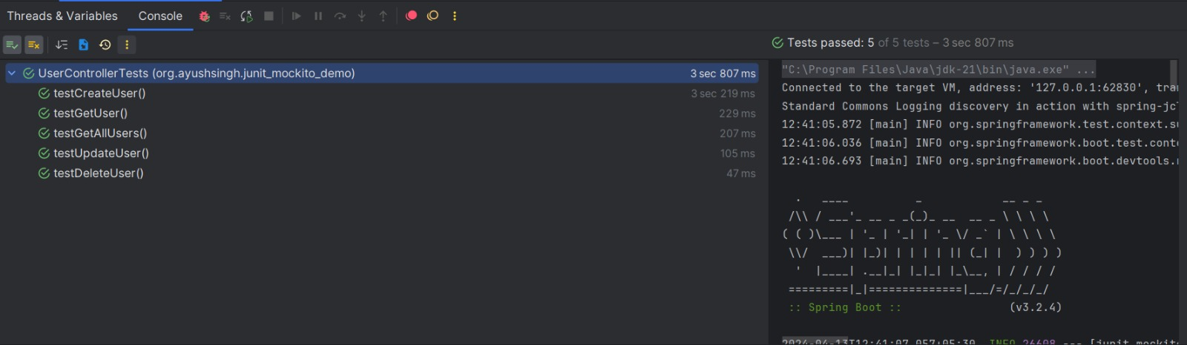

# Test using Junit and Mockito

package org.ayushsingh.junit_mockito_demo;  
  
import org.ayushsingh.junit_mockito_demo.dto.UserDetailsDto;  
import org.ayushsingh.junit_mockito_demo.dto.UserRegisterDto;  
import org.ayushsingh.junit_mockito_demo.entity.User;  
import org.ayushsingh.junit_mockito_demo.repository.UserRepository;  
import org.ayushsingh.junit_mockito_demo.service.impl.UserServiceImpl;  
import org.junit.jupiter.api.MethodOrderer;  
import org.junit.jupiter.api.Order;  
import org.junit.jupiter.api.Test;  
import org.junit.jupiter.api.TestMethodOrder;  
import org.junit.jupiter.api.extension.ExtendWith;  
import org.mockito.InjectMocks;  
import org.mockito.Mock;  
import org.springframework.test.context.junit.jupiter.SpringExtension;  
  
import java.util.Arrays;  
import java.util.List;  
import java.util.Optional;  
  
import static org.junit.jupiter.api.Assertions.*assertEquals*;  
import static org.junit.jupiter.api.Assertions.*assertNotNull*;  
import static org.mockito.Mockito.*;  
  
  
*/**  
 * Unit tests for the {@link UserServiceImpl}.  
 * This class tests the CRUD operations using Mockito  
 *  
 * @author Ayush Singh  
 * @since 2024-04-12  
 * @version 1.0.0  
 */*@ExtendWith(SpringExtension.class)  
@TestMethodOrder(MethodOrderer.OrderAnnotation.class)  
public class UserServiceTests {  
  
 @Mock  
 private UserRepository userRepository;  
  
 @InjectMocks  
 private UserServiceImpl userService;  
  
 @Test  
 @Order(1)  
 void testCreateUser() {  
 UserRegisterDto userRegisterDto = UserRegisterDto.*builder*()  
 .username("ayush")  
 .password("123abc")  
 .name("Ayush Singh")  
 .email("ayushsingh20november@gmail.com")  
 .phone(1234567890L)  
 .build();  
 User savedUser = new User(1L, "ayush", "123abc", "Ayush Singh", "ayushsingh20november@gmail.com", 1234567890L);  
 *when*(userRepository.save(*any*(User.class))).thenReturn(savedUser);  
  
  
 UserDetailsDto actualUserDto = userService.createUser(userRegisterDto);  
  
  
 *assertNotNull*(actualUserDto.getUserId());  
 *assertEquals*(userRegisterDto.getUsername(), actualUserDto.getUsername());  
 *assertEquals*(userRegisterDto.getName(), actualUserDto.getName());  
 *assertEquals*(userRegisterDto.getEmail(), actualUserDto.getEmail());  
 *assertEquals*(userRegisterDto.getPhone(), actualUserDto.getPhone());  
 *verify*(userRepository, *times*(1)).save(*any*(User.class));  
 }  
  
 @Test  
 @Order(2)  
 void testGetUser() {  
  
 Long userId = 1L;  
 User user = new User(userId, "ayush", "123abc", "Ayush Singh", "ayushsingh20november@gmail.com", 7867564563L);  
 *when*(userRepository.findById(userId)).thenReturn(Optional.*of*(user));  
  
  
 UserDetailsDto actualUserDto = userService.getUser(userId);  
  
  
 *assertEquals*(user.getUserId(), actualUserDto.getUserId());  
 *verify*(userRepository, *times*(1)).findById(userId);  
 }  
  
 @Test  
 @Order(3)  
 void testUpdateUser() {  
  
 User user = new User(1L, "ayush", "123abc", "Ayush Singh", "ayushsingh20november@gmail.com", 7867564563L);  
 User expectedUpdatedUser = new User(1L, "himanshu", "123abc123", "Himanshu Singh", "himanshur@gmail.com", 7867564563L);  
 *when*(userRepository.findById(1L)).thenReturn(Optional.*of*(user));  
 *when*(userRepository.save(*any*(User.class))).thenReturn(expectedUpdatedUser);  
  
 UserDetailsDto userDto = new UserDetailsDto(1L,"himanshu", "Himanshu Singh", "himanshur@gmail.com", 7867564563L);  
 UserDetailsDto updatedUserDto = userService.updateUser(userDto);  
  
  
 *assertEquals*(userDto.getUserId(), updatedUserDto.getUserId());  
 *assertEquals*(userDto.getUsername(), updatedUserDto.getUsername());  
 *assertEquals*(userDto.getName(), updatedUserDto.getName());  
 *assertEquals*(userDto.getEmail(), updatedUserDto.getEmail());  
 *assertEquals*(userDto.getPhone(), updatedUserDto.getPhone());  
 *verify*(userRepository, *times*(1)).findById(1L);  
 *verify*(userRepository, *times*(1)).save(*any*(User.class));  
 }  
  
  
  
 @Test  
 @Order(4)  
 void testDeleteUser() {  
 Long userId = 1L;  
  
  
 userService.deleteUser(userId);  
  
 *verify*(userRepository, *times*(1)).deleteById(userId);  
 }  
  
  
 @Test  
 @Order(5)  
 void testGetAllUsers() {  
  
 User user1 = new User(1L, "ayush", "123abc", "Ayush Singh", "ayushsingh20november@gmail.com", 7867564563L);  
 User user2 = new User(2L, "himanshu", "123abc123", "Himanshu Singh", "himanshur@gmail.com", 7867564563L);  
 *when*(userRepository.findAll()).thenReturn(Arrays.*asList*(user1, user2));  
 List<UserDetailsDto> expectedUserDtos = Arrays.*asList*(  
 new UserDetailsDto(1L, "ayush", "Ayush Singh", "ayushsingh20november@gmail.com", 7867564563L),  
 new UserDetailsDto(2L, "himanshu", "Himanshu Singh", "himanshur@gmail.com", 7867564563L)  
 );  
  
  
 List<UserDetailsDto> actualUserDtos = userService.getAllUsers();  
  
  
 *assertEquals*(expectedUserDtos.size(), actualUserDtos.size());  
 for (int i = 0; i < expectedUserDtos.size(); i++) {  
 *assertEquals*(expectedUserDtos.get(i).getUserId(), actualUserDtos.get(i).getUserId());  
 }  
 *verify*(userRepository, *times*(1)).findAll();  
 }  
  
  
}

## Test Results

